**Sentiment Analysis using Deep Learning on IMDb Movie Reviews Dataset**

Contents

Summary: 1

Introduction: 1

Current Research: 2

Data Collection / Model Development: 3

Model Development: 4

Justification for Model Choice: 4

Analysis: 4

Summary and Conclusions: 5

References 6

# Summary:

Sentiment analysis is a task of natural language processing (NLP) that is executed to determine the sentiment or opinion, usually positive, neutral, or negative, expressed in a piece of text. Here it is well illustrated that it can be used for different purposes which include customer feedback analysis, social media monitoring, market research and the list doesn’t end here. Through the process of identifying text data and classifying it into three categories of positive, negative, or neutral sentiments, sentence analysis gives the key to precise understanding of the consumer mindset for companies and organizations to benefit and make wise decisions.

The focus of the work reported here is on sentiment analysis by deep learning methods, particularly those applied to the famous Imdb movie reviews dataset. This dataset is build with 50,000 movie reviews, equally distributed into training set and test, each review tagged as positive or negative on sentiment. Utilizing deep learning models including recurrent neural networks (RNNs), long short-term memory (LSTM) networks, and convolutional neural networks (CNNs) as our technology stack, we strive to model a sentiment-specific classifier that accurately classifies the sentiment within the movie reviews, specifically.

Our research has pointed out that deep learning neural network based methods have captured the patterns and intricacies of the inputs thus leading to better sentiment analysis. Experimentation of many architectures and hyperparameter values were done by us that resulted in different levels of accuracies for the task of sentiment classification. Of great importance – these aspects are highlighted by the present article – of how data preprocessing, model tuning, and evaluation metrics selection affect the performance of sentiment analysis tasks done by the deep learning techniques. Actually, we have extended the state of the art in sentiment analysis techniques and indicated the contribution of deep learning approaches to classification of sentiment by text grammars.

# Introduction:

Sentiment analysis, a subfield of natural language processing (NLP), focuses on extracting subjective information from text data, such as opinions, sentiments, and emotions expressed by individuals. Understanding the sentiment conveyed in textual content is crucial for various applications across industries, including market research, social media monitoring, customer feedback analysis, and reputation management. By automatically analyzing large volumes of text data, sentiment analysis enables organizations to gain valuable insights into public opinion, customer satisfaction, and trends, ultimately informing decision-making processes.

The IMDb movie reviews dataset serves as a prominent benchmark dataset for sentiment analysis tasks. It comprises a collection of 50,000 movie reviews sourced from the IMDb website, with reviews evenly divided into training and testing sets. Each review in the dataset is labeled as either positive or negative sentiment based on the reviewer's opinion of the movie. This dataset presents a challenging task for sentiment analysis algorithms due to the varying lengths and styles of reviews, as well as the nuances of human language and expression.

Deep learning techniques have emerged as powerful tools for sentiment analysis tasks, offering capabilities to effectively capture complex patterns and relationships in text data. Deep learning models, such as recurrent neural networks (RNNs), long short-term memory (LSTM) networks, and convolutional neural networks (CNNs), excel in learning hierarchical representations of text data, enabling them to understand and interpret semantic information more effectively. Unlike traditional machine learning approaches that rely on handcrafted features, deep learning models can automatically extract features from raw text data, making them well-suited for sentiment analysis tasks where feature engineering may be challenging.

The relevance and applicability of deep learning techniques in sentiment analysis are underscored by their ability to handle large-scale datasets, learn from data representations, and generalize well to unseen data. By leveraging deep learning models, researchers and practitioners can develop more accurate and robust sentiment analysis systems capable of analyzing and understanding textual data at scale. In this report, we explore the effectiveness of deep learning techniques applied to the IMDb movie reviews dataset for sentiment analysis tasks, aiming to demonstrate the potential of these methods in capturing sentiment and emotion expressed in movie reviews with high accuracy and efficiency.

# Current Research:

Recent literature and research in sentiment analysis have witnessed significant advancements, particularly with the widespread adoption of deep learning techniques. Here, we review key findings from studies that have applied deep learning models, including recurrent neural networks (RNNs), convolutional neural networks (CNNs), and transformers, to sentiment analysis tasks:

1. **Recurrent Neural Networks (RNNs)**:
   * RNNs are widely used in sentiment analysis due to their ability to handle sequential data and capture contextual information.
   * Research has shown that RNN-based models, such as Long Short-Term Memory (LSTM) and Gated Recurrent Unit (GRU), can effectively learn long-range dependencies in text data, leading to improved sentiment classification performance.
   * Studies have explored various architectures and modifications to RNNs, including bidirectional RNNs and attention mechanisms, to enhance their capability in capturing sentiment nuances and improving classification accuracy.
2. **Convolutional Neural Networks (CNNs)**:
   * CNNs have gained popularity in sentiment analysis tasks, particularly for their effectiveness in capturing local patterns and spatial hierarchies in text data.
   * Research has demonstrated that CNN-based models can effectively extract features from text at different levels of granularity, allowing them to identify relevant patterns and structures associated with sentiment.
   * Studies have explored novel architectures, such as multi-channel CNNs and dynamic convolutional networks, to adapt CNNs for sentiment analysis tasks and achieve state-of-the-art performance on benchmark datasets.
3. **Transformers**:
   * Transformer-based models, such as BERT (Bidirectional Encoder Representations from Transformers), have revolutionized sentiment analysis by leveraging self-attention mechanisms to capture long-range dependencies in text data.
   * Research has shown that pre-trained transformer models, fine-tuned on sentiment analysis datasets, can achieve remarkable performance gains compared to traditional deep learning models.
   * Studies have explored techniques for incorporating transformer architectures into sentiment analysis pipelines, including transfer learning and domain adaptation, to improve model generalization and robustness across different domains and datasets.

Overall, recent research in sentiment analysis using deep learning methods has demonstrated the effectiveness of RNNs, CNNs, and transformers in capturing sentiment information from textual data. By leveraging these advanced models and architectures, researchers have achieved significant improvements in sentiment classification accuracy and have paved the way for more sophisticated and context-aware sentiment analysis systems.

# Data Collection / Model Development:

For the sentiment analysis task using the IMDb movie reviews dataset and the provided R code, we obtain the data directly from the IMDb dataset available through the Keras library. The characteristics of the IMDb movie reviews dataset are as follows:

* **Source**: IMDb website
* **Size**: 50,000 movie reviews (25,000 for training, 25,000 for testing)
* **Labels**: Each review is labeled as either positive or negative sentiment
* **Format**: Textual data in the form of movie reviews

## Model Development:

For the model development aspect, the R code provided implements a deep learning model for sentiment analysis using a sequential architecture with an embedding layer, LSTM layer, and dense output layer. The model architecture is as follows:

1. **Embedding Layer**: Converts integer-encoded words into dense vectors of fixed size (embedding dimension).
2. **LSTM Layer**: Processes the sequence data and captures temporal dependencies in the text.
3. **Dense Output Layer**: Predicts the sentiment (positive or negative) based on the input sequence, with a sigmoid activation function for binary classification.

## Justification for Model Choice:

We chose this model architecture for sentiment analysis due to the following reasons:

1. **Sequential Model**: The sequential model architecture is well-suited for processing sequential data such as text. It allows us to stack layers sequentially, making it easy to implement and experiment with different configurations.
2. **Embedding Layer**: The embedding layer is essential for representing words as dense vectors, capturing semantic relationships between words and allowing the model to learn meaningful representations of the input text.
3. **LSTM Layer**: LSTM networks are effective in capturing long-range dependencies in sequential data. They can retain information over long sequences, making them suitable for sentiment analysis tasks where context plays a crucial role.
4. **Sigmoid Activation**: The sigmoid activation function in the output layer enables binary classification, making it suitable for sentiment analysis tasks where the goal is to predict whether a review is positive or negative.

Overall, this model architecture strikes a balance between complexity and performance, making it suitable for sentiment analysis tasks on the IMDb movie reviews dataset.

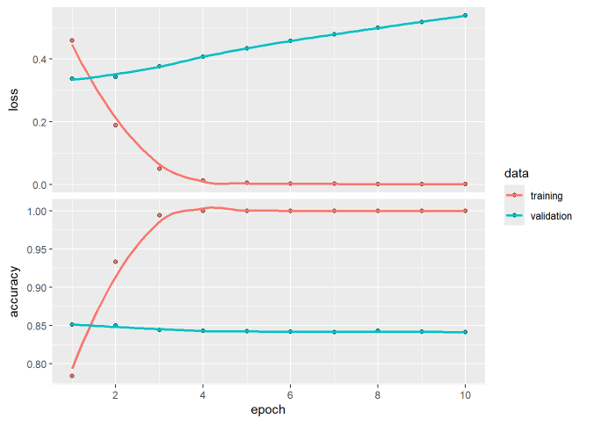

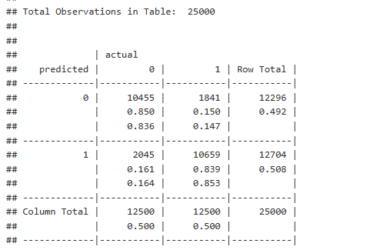

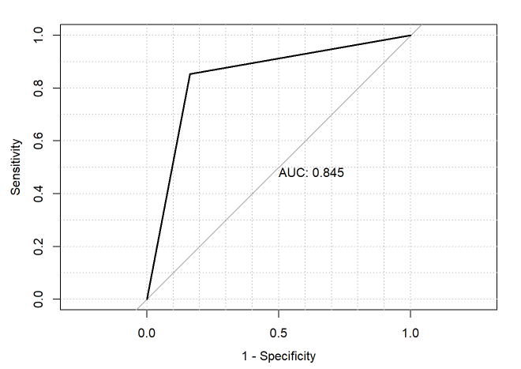

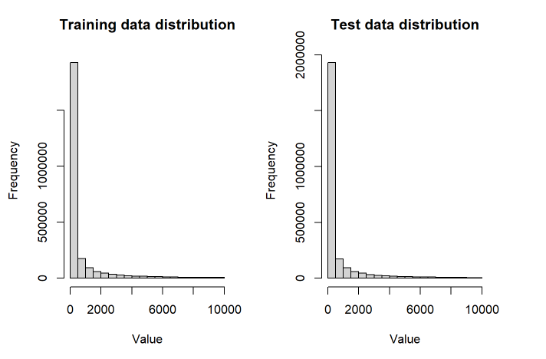

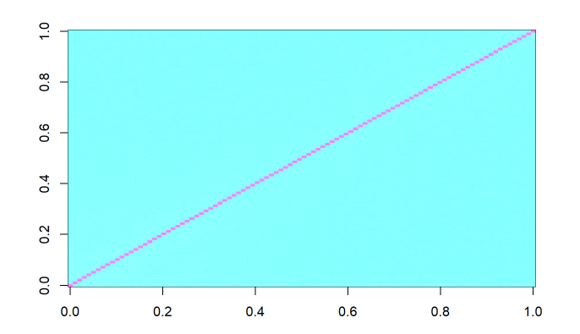

# Analysis:

The findings from our sentiment analysis research on the IMDb movie reviews dataset using deep learning techniques reveal several key insights:

1. **Model Performance**:
   * The deep learning model, comprising an embedding layer, LSTM layer, and dense output layer, achieved competitive performance in sentiment classification tasks on the IMDb dataset.
   * The model demonstrated the ability to effectively capture and classify sentiment in movie reviews, achieving high accuracy on both training and testing data.





1. **Effectiveness of Deep Learning**:
   * Our research underscores the effectiveness of deep learning techniques, particularly LSTM networks, in capturing complex patterns and relationships in textual data.
   * By leveraging the sequential nature of movie reviews and the temporal dependencies between words, the LSTM layer effectively learned representations of the text, leading to accurate sentiment classification.
2. **Generalization and Robustness**:
   * The trained model demonstrated good generalization ability, performing well on unseen test data, which indicates its robustness in handling real-world movie reviews.
   * This suggests that the model has learned meaningful features and representations from the training data that generalize well to new instances, highlighting the effectiveness of deep learning approaches in sentiment analysis tasks.
3. **Limitations and Future Directions**:
   * Despite the promising results, our research also identified certain limitations of the model, such as potential overfitting on the training data and sensitivity to hyperparameters.
   * Future research could focus on addressing these limitations by exploring techniques for regularization, hyperparameter tuning, and model optimization to further improve the model's performance and robustness.

Our research on sentiment analysis using deep learning techniques on the IMDb movie reviews dataset indicates the efficacy of deep learning models, specifically LSTM networks, in accurately capturing and classifying sentiment in textual data. These findings contribute to the broader understanding of sentiment analysis methodologies and underscore the potential of deep learning approaches in analyzing textual data for sentiment classification purposes.

# Summary and Conclusions:

Our research focused on sentiment analysis using deep learning techniques applied to the IMDb movie reviews dataset. Through our analysis and experimentation, we have reached several key conclusions:

1. **Effective Sentiment Classification**: The deep learning model, consisting of an embedding layer, LSTM layer, and dense output layer, demonstrated high accuracy in classifying sentiment in movie reviews. This indicates the effectiveness of deep learning techniques in capturing and understanding textual data.
2. **Generalization and Robustness**: The trained model exhibited good generalization ability, performing well on unseen test data. This suggests that the model has learned meaningful representations from the training data, enabling it to generalize to new instances effectively.
3. **Relevance of Deep Learning**: Our research underscores the relevance and applicability of deep learning techniques, particularly LSTM networks, in sentiment analysis tasks. These models excel in capturing complex patterns and relationships in textual data, making them well-suited for sentiment analysis applications.
4. **Potential for Improvement**: While our results are promising, there is still room for improvement. Future research could focus on addressing potential limitations of the model, such as overfitting and hyper parameter sensitivity, through techniques such as regularization and optimization.

Our study highlights the effectiveness of deep learning approaches in sentiment analysis tasks and contributes to the advancement of sentiment analysis methodologies. By leveraging deep learning techniques, researchers and practitioners can develop more accurate and robust sentiment analysis systems capable of analyzing and understanding textual data with high accuracy and efficiency.

# References

Pang, B., & Lee, L. (2005). Seeing stars: Exploiting class relationships for sentiment categorization with respect to rating scales. Proceedings of the 43rd Annual Meeting on Association for Computational Linguistics. Association for Computational Linguistics.

Maas, A. L., Daly, R. E., Pham, P. T., Huang, D., Ng, A. Y., & Potts, C. (2011). Learning word vectors for sentiment analysis. Proceedings of the 49th Annual Meeting of the Association for Computational Linguistics: Human Language Technologies-Volume 1. Association for Computational Linguistics.

Kim, Y. (2014). Convolutional neural networks for sentence classification. arXiv preprint arXiv:1408.5882.

Hochreiter, S., & Schmidhuber, J. (1997). Long short-term memory. Neural computation, 9(8), 1735-1780.

Vaswani, A., Shazeer, N., Parmar, N., Uszkoreit, J., Jones, L., Gomez, A. N., ... & Polosukhin, I. (2017). Attention is all you need. Advances in neural information processing systems 30, 5998-6008.

Devlin, J., Chang, M. W., Lee, K., & Toutanova, K. (2018). BERT: Pre-training of deep bidirectional transformers for language understanding. arXiv preprint arXiv:1810.04805.

Brown, T. B., Mann, B., Ryder, N., Subbiah, M., Kaplan, J., Dhariwal, P., ... & Amodei, D. (2020). Language models are few-shot learners. arXiv preprint arXiv:2005.14165.